# *Estimation and Prediction of Hospitalization and Medical Care Costs*

**INTRODUCTION**

**Overview:**

**M**edical costs are one of the most common recurring expenses in a person's life. Based on different research studies, BMI, ageing, smoking, and other factors are all related to greater personal medical care costs.

The estimates of the expenditures of health care related to obesity are needed to help create cost-effective obesity prevention strategies. Obesity prevention at Young age is a top concern in global health, clinical practice, and public health.

**Purpose:**

The main objective of cost accounting are ascertainment of cost, fixation of

Selling price, proper recording and presentation of cost data to management for measuring

Efficiency and for cost control and cost reduction, ascertaining the profit of each activity,

Assisting management in decision making process.

**Literature Survey**

**Existing Problems in Medical Care:**

## **The High Cost of Health Care.**

## **The Concerns of Health Equity.**

## **The Promise (and Pitfalls) of Technology.**

## **The Move toward Value-Based Care.**

## **The Growing Provider Shortage.**

**Proposed Solution For Medical Care Cost:**

**The following are some solutions in medical care costs**

1. **Expand Insurance to Cover Health Care Costs.**
2. **Extend TELE health Services.**
3. **Invest in Mobile Clinics.**
4. **Educate The Public About Multiple Health Care Sites.**
5. **Improve Cultural Responsiveness.**

THEORITICAL ANALYSIS:

The self-service capabilities of this platform allow users to build their own dashboards,

Reports and scorecards in a simple, intuitive and secure way. It also **provides ease of use for**

**Advanced data analysis**.

**Block Diagram**

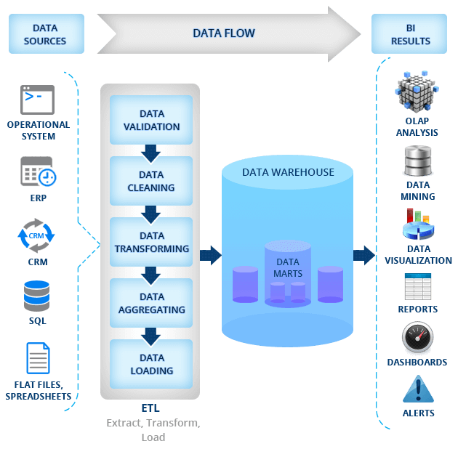

Hardware & Software Designing

Hardware Requirements:

* 11th Generation Intel® Core™ i5 processor
* 35.6 cm (14) diagonal Bright view 1920X1080 & ® Xᵉ Graphics
* 512 GB SSD Hard drive
* 8 GB DDR4-3200 MHz RAM

Software Requirements:

* Anaconda Navigator
* Python, Spider
* IBM COGNOS
* MS Word

RESULT:

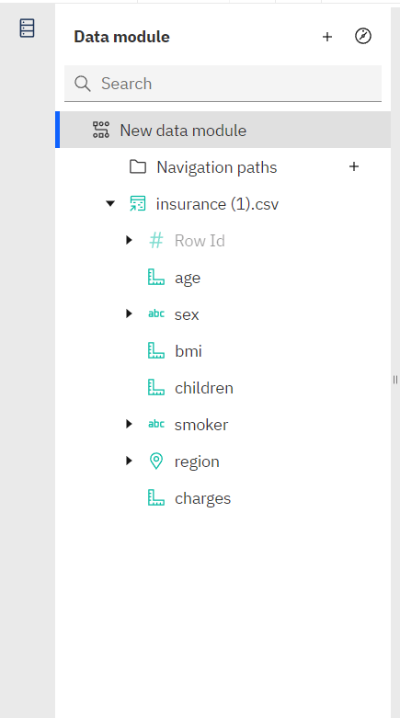

**Dashboard**

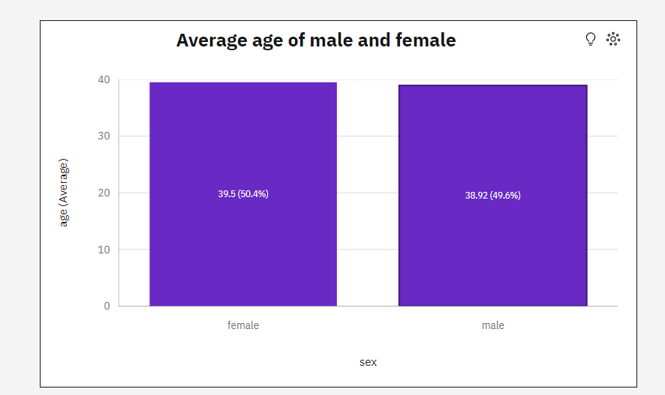

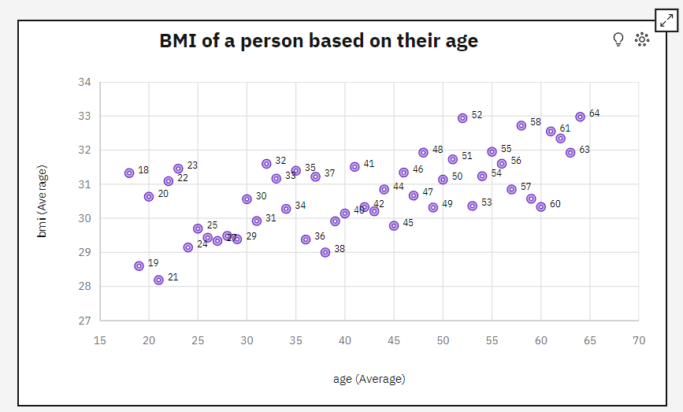

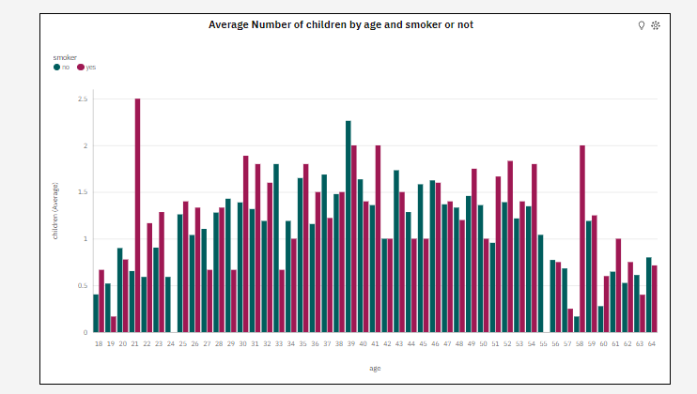

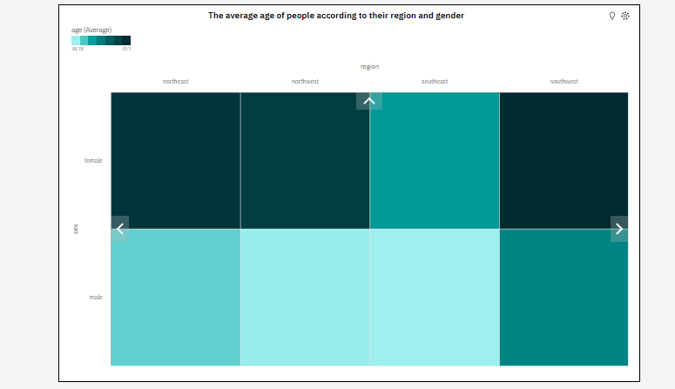

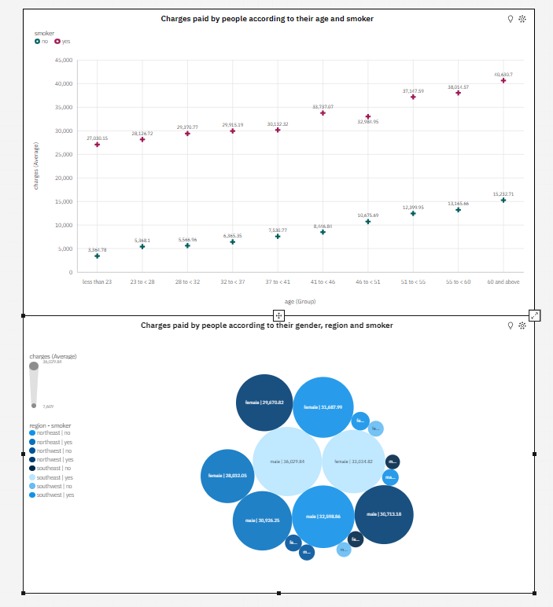

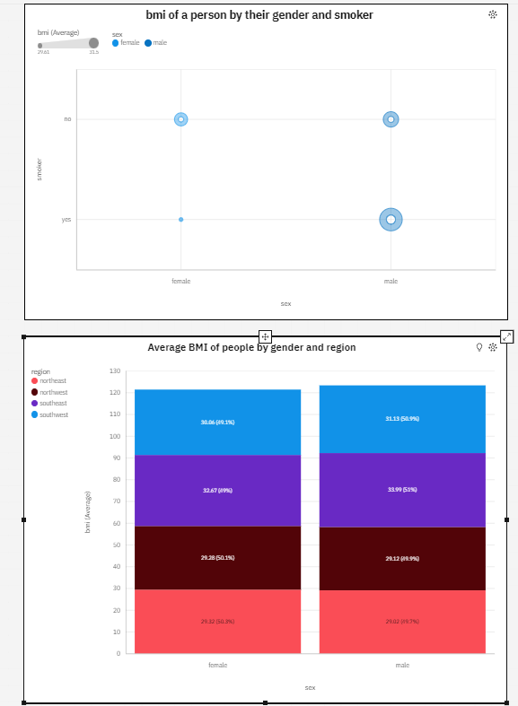

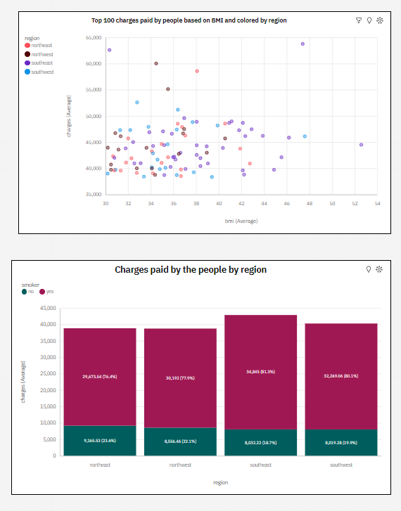

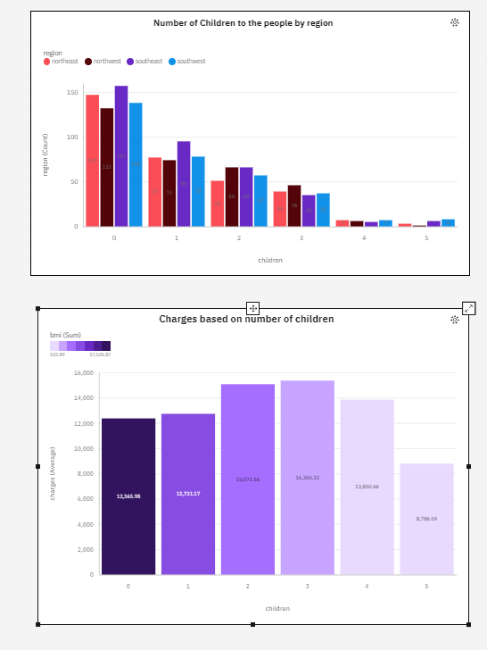

**Story**

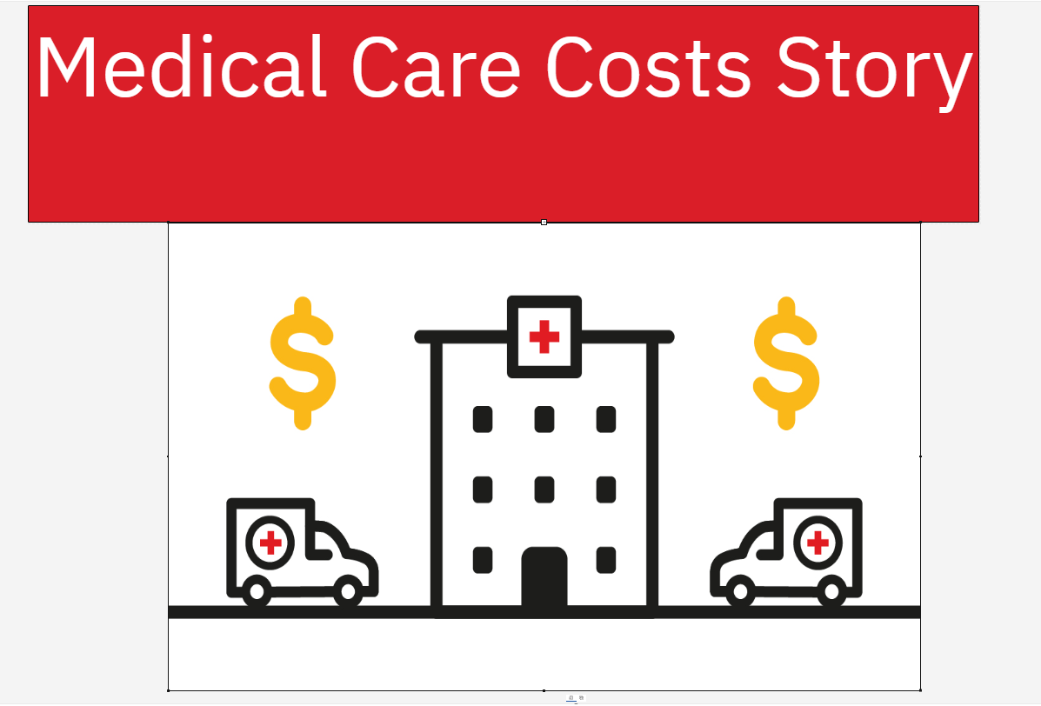

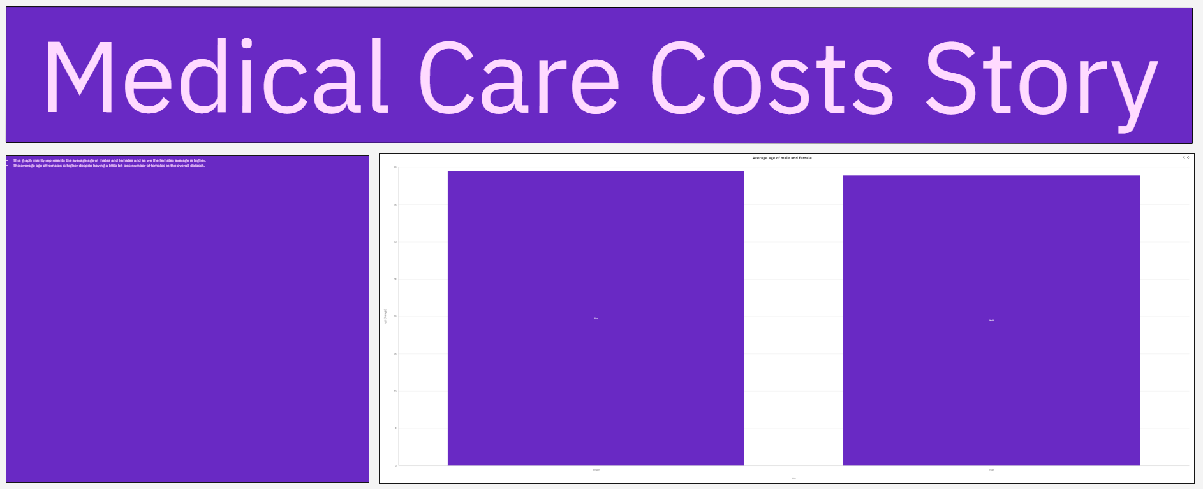

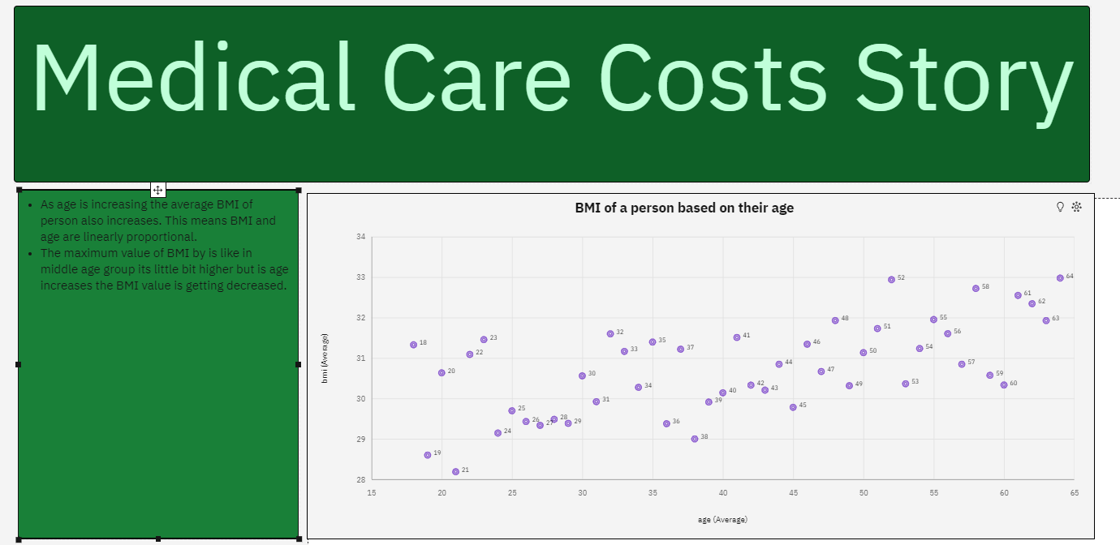

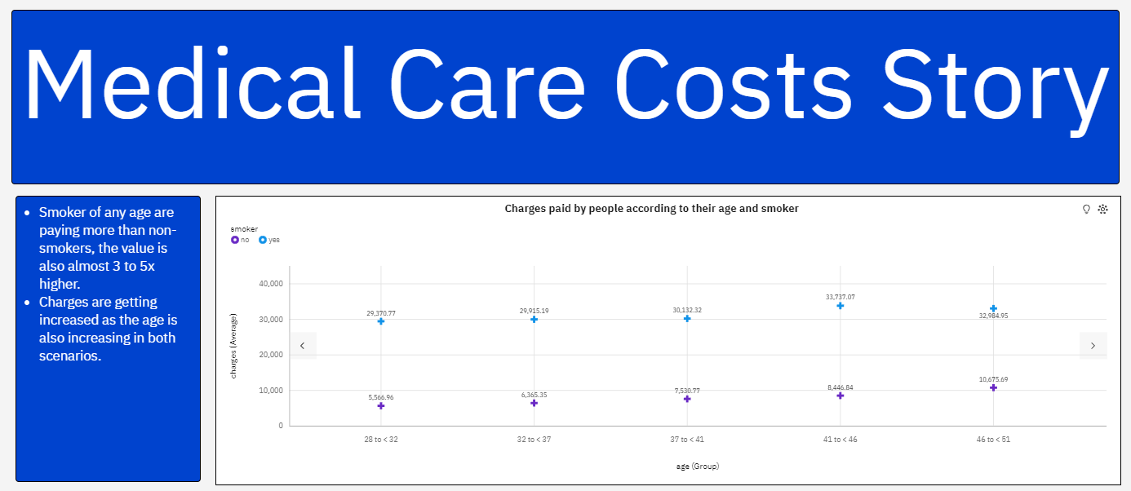

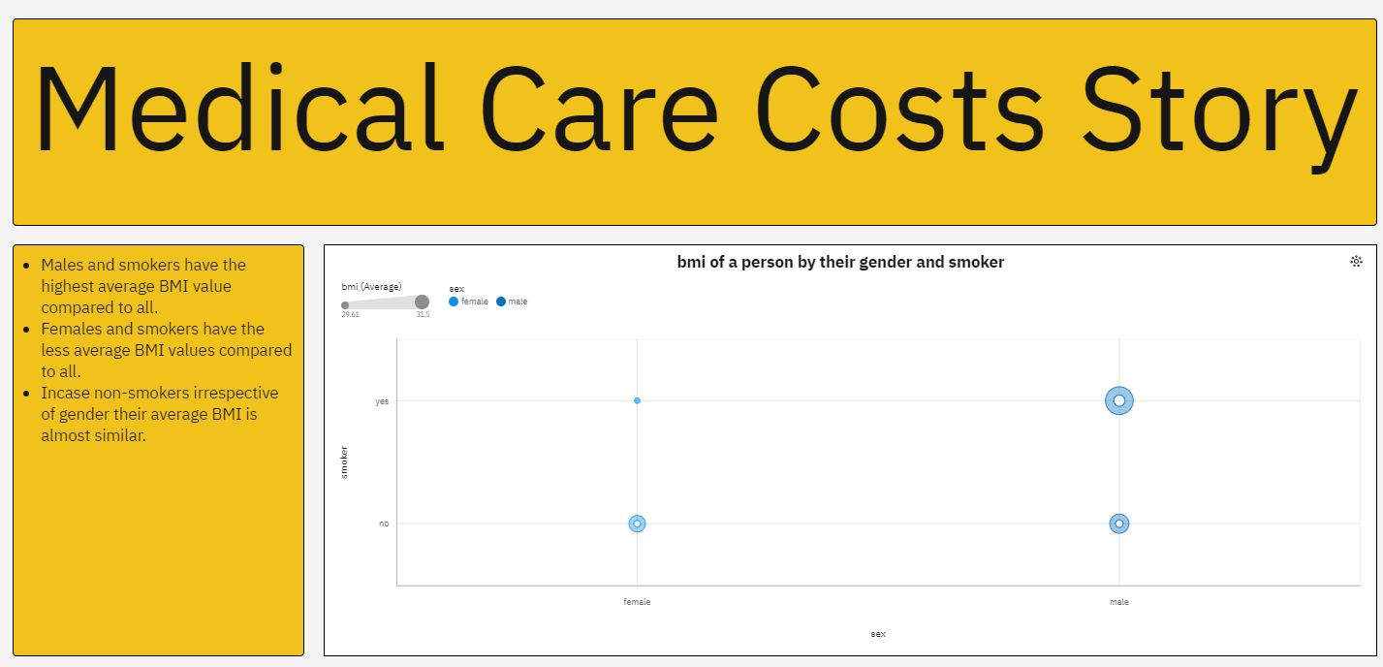

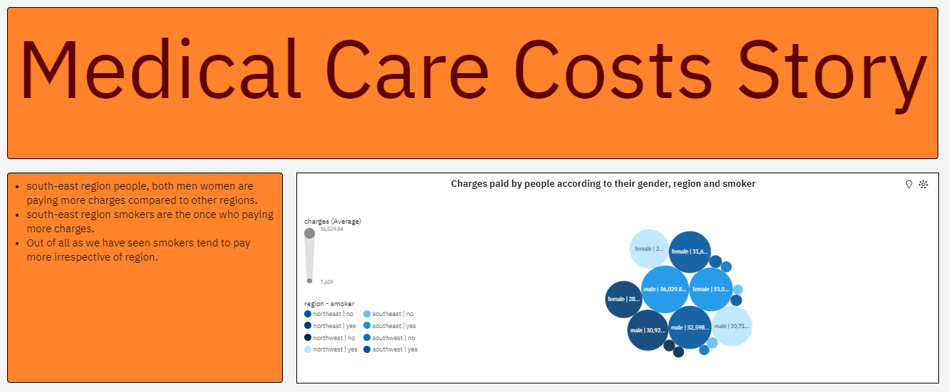

**Report**





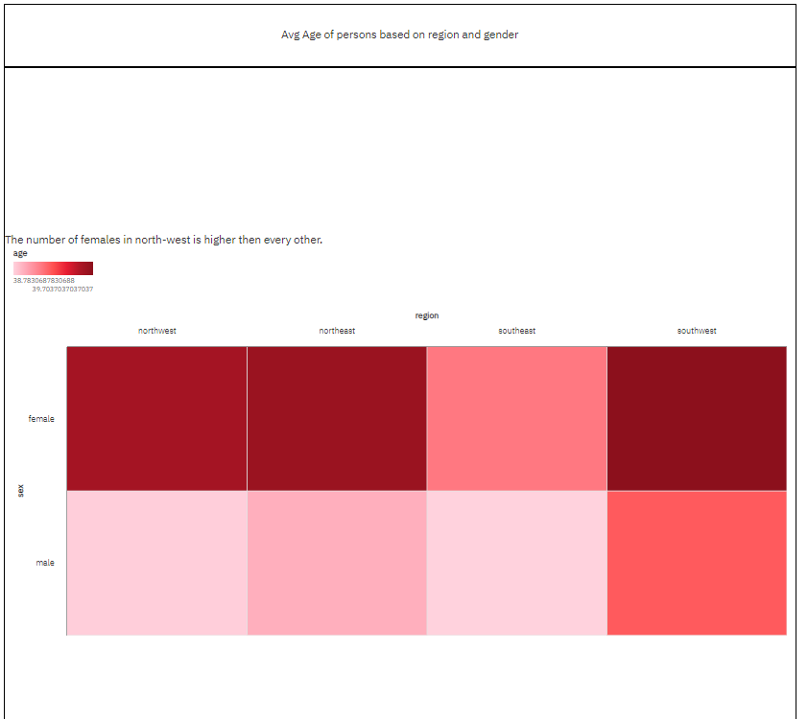

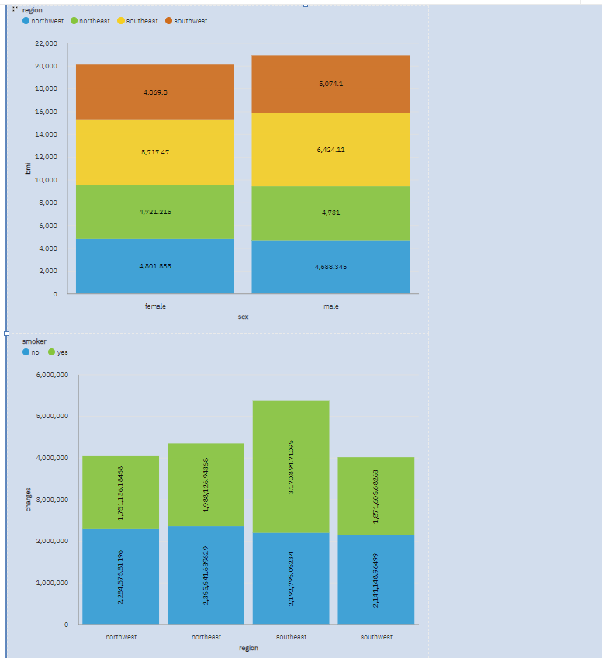

**Web Integration**

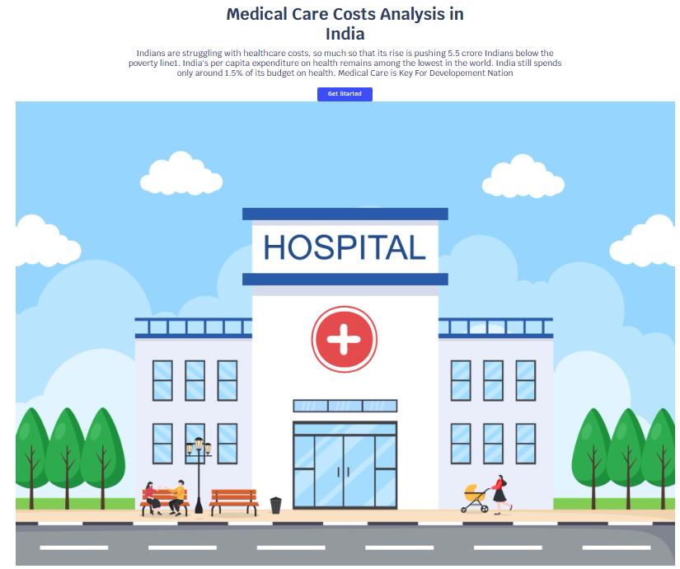

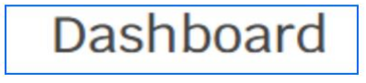

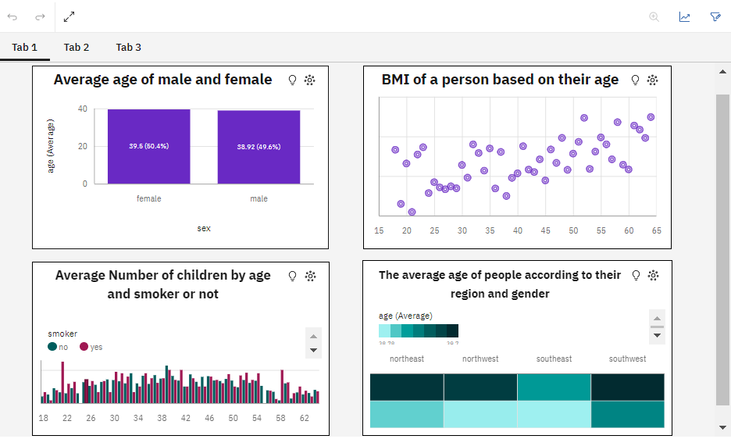

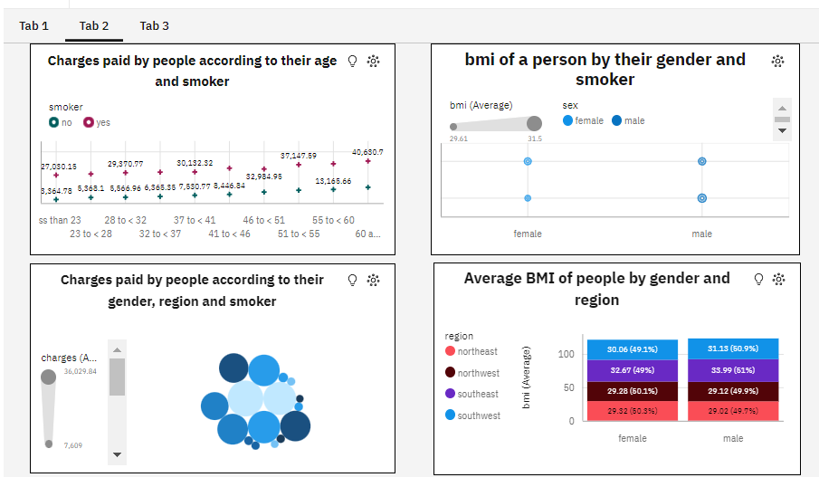

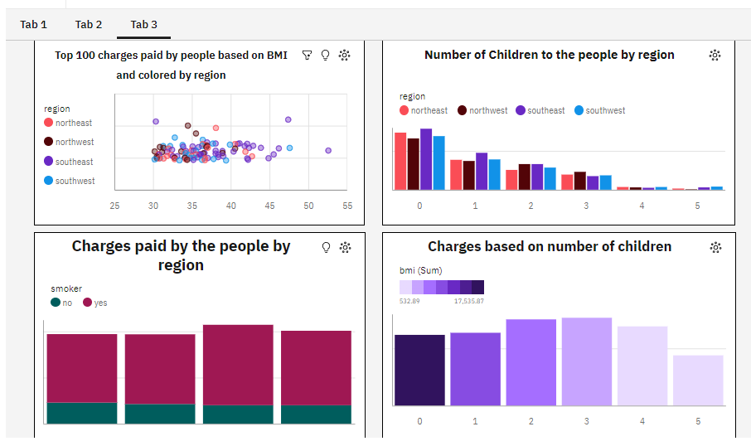



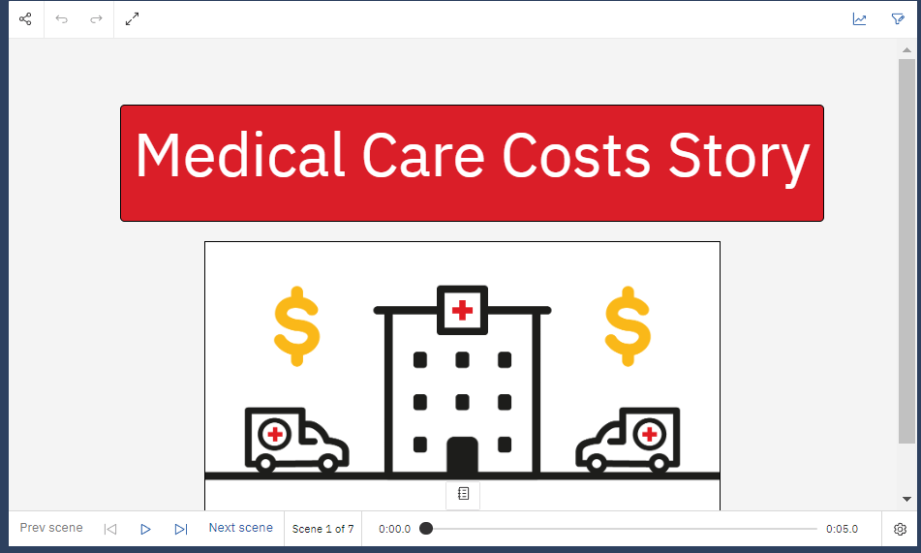

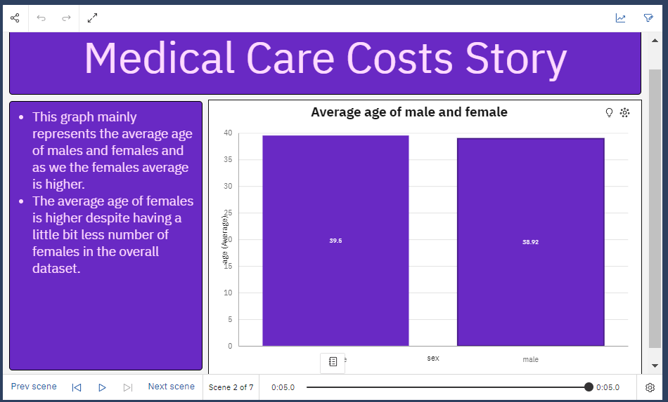

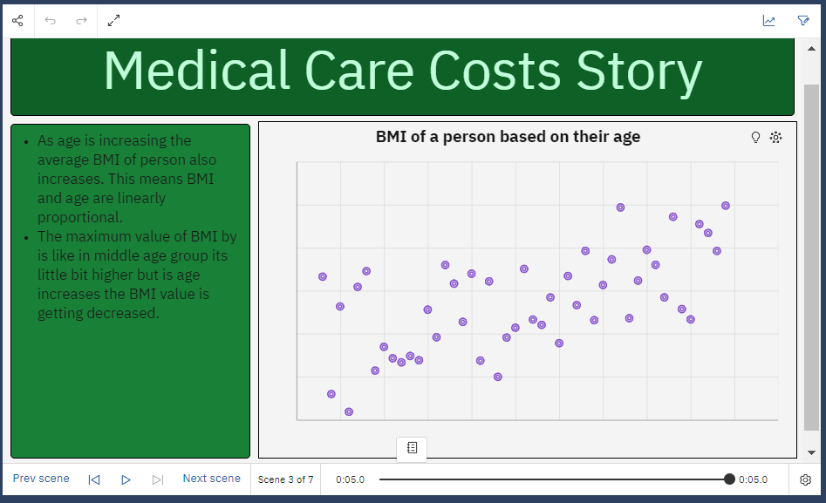

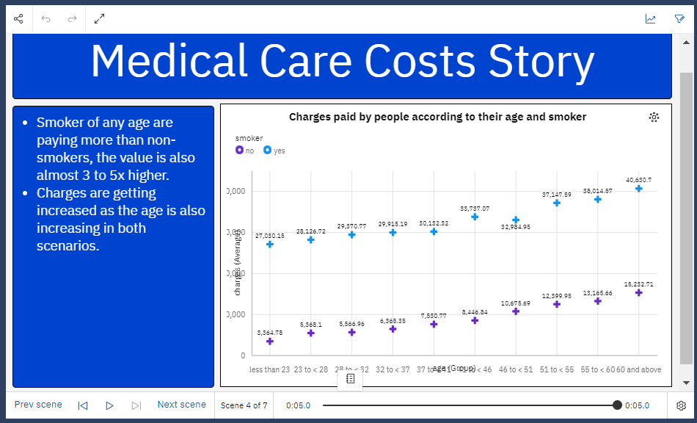

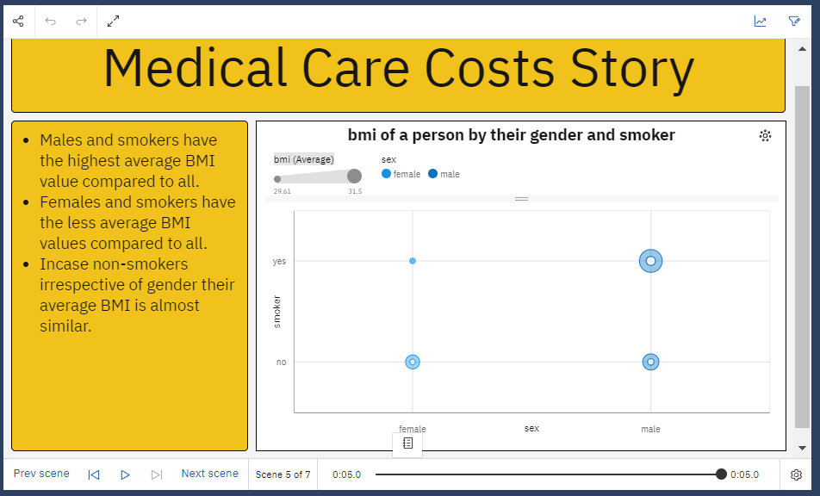

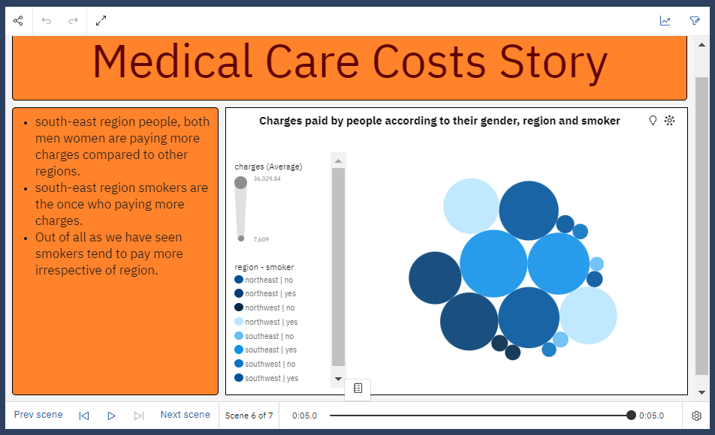

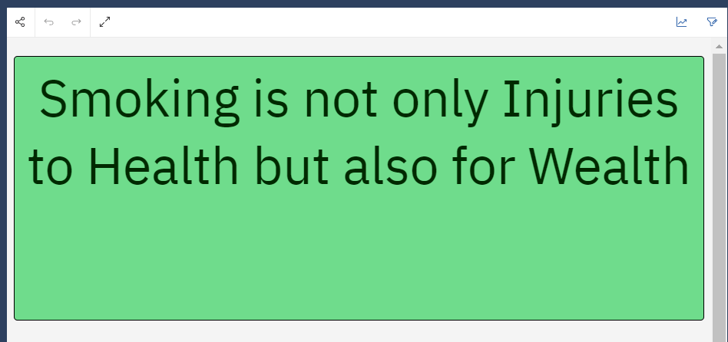



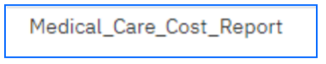

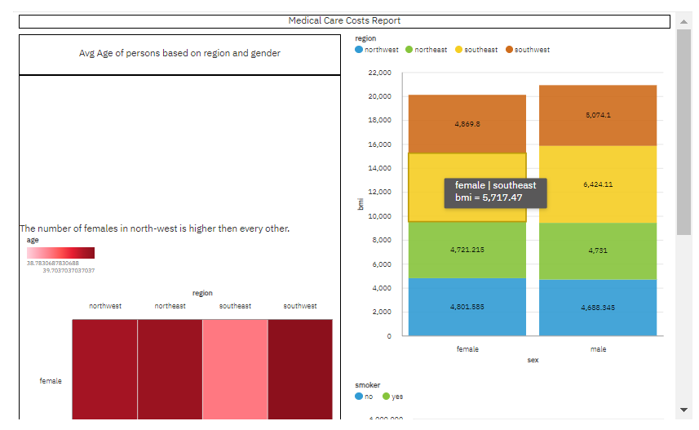

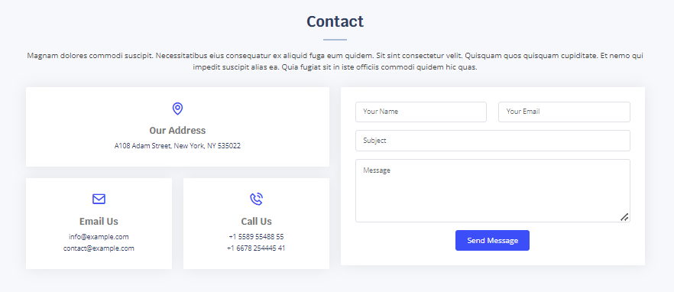

**Advantages & Disadvantages**

**Advantages:**

IBM provides powerful data visualization, Dash Boarding, and reporting capabilities that help

users quickly and easily access relevant insights. This allows businesses to make data-driven

decisions more efficiently and effectively.

* Higher ground gave the enemy the/an advantage.
* He has/enjoys an unfair advantage over us because of his wealth.
* His plan has the advantage of being less expensive than other options.
* He lacked the advantages of an advanced education.
* Speed is an advantage in most sports.
* External Failure Costs.

**Disadvantages:**

IBM COGNOS  **are some small features that are missing**. It would be nice if the

graphics were better. You can use external sources for charts, but it's quite complex to use and

not easy to implement.

**.**Services are intangible.

· The provider is the product.

· They're perishable.

· Quality can vary from day to day.

**Application:**

* IBM Benefits Summary. Health & Well being.
* Family Support. Tax-Advantaged Spending Accounts. Financial Benefits.
* Time Off & Leaves. Enrolling in Benefits. Resources.
* IBM COGNOS Business Intelligence is a web-based integrated business intelligence suite by IBM. It **provides a tool set for reporting and monitoring of events and metrics**. The software consists of several components designed to meet the different information requirements in a company.
* Predictive Analytics in healthcare **predicts future patient outcomes and identifies what treatment to give patients based on their health condition**. Standard techniques used in predictive analysis include machine learning, statistical modeling, and data mining.

**Conclusion:**

IBM's mission statement is “to lead in the creation, development and manufacture

of the industry's most advanced information technologies, including computer systems, software,

networking systems, storage devices and microelectronics.

**Future Scope:**

IBM plays a critical role in the health industries our solutions, services and innovations are

enabling the future for healthcare and life sciences.

* 'Eagle' heralded a 127-qubit quantum breakthrough.
* Skills training pledged for 30 million learners.
* IBM Research started teaching AI to write code.
* The launch of IBM Consulting.
* An autonomous ship explored our oceans.
* The future of 'zero trust' got even more secure.